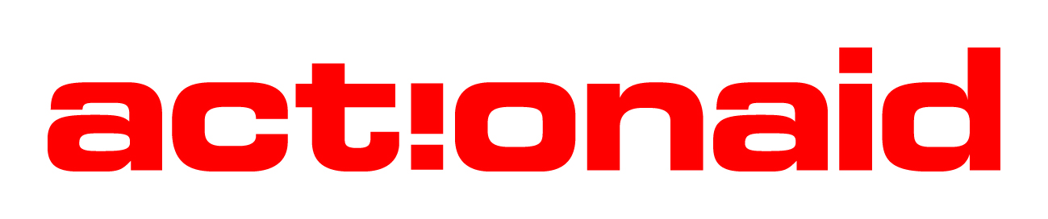

JOB DESCRIPTION

Job Title: Social Media Intern

Location: Abuja

Responsible to: Communications Coordinator

Duration: 12 months contract

Summary
The Intern position is an opportunity offered by ActionAid Nigeria (AAN) for young graduates to earn a post NYSC experience. It is therefore both a learning and value-adding relationship between interns and AAN. The intern is expected to take advantage of the space offered for experience gathering, self-development, while providing quality service to ActionAid Nigeria

Job Purpose

The Social Media Intern will be responsible for strategically managing and enhancing the ActionAid Nigeria’s online presence, utilising social media platforms to amplify the organisation's impact, showcase AAN’s contributions to social justice, policy engagement, advocacy and humanitarian work, and engage with diverse stakeholders. This role requires exercising thorough discretion and upholding the principles of confidentiality, particularly in sensitive situations.

Specific Duties & Responsibilities:
- Content Creation:
- Develop engaging and relevant content for ActionAid Nigeria’s social media platforms of ActionAid Nigeria, ensuring that curated content aligns with the organisation’s mission and values.
- Curate and share innovative multimedia content and designs (graphics, videos, infographics, doodles, photos) that showcase the professional achievements, thought leadership, and positive impact of ActionAid Nigeria’s engagements and activities.
- Brand Representation:
- Effectively represent AAN’s brand on social media platforms, ensuring alignment with ActionAid's overall mission and values
- Encourage and facilitate the sharing of insightful articles, blogs, and opinion pieces authored by staff of ActionAid, positioning the organisation as a thought leader in relevant areas.
- Ensure that AAN’s social media presence aligns with emerging topics and conversations to foster engagement and relevance
- Social media management:
- Regularly update and maintain the social media accounts under the guidance and approval of the Communications Coordinator.
- Monitor and respond to comments, messages, and mentions on the social media platforms.
Key Working Relationships
- Internal Relationships: Entire AAN team
- External Relationships: Project Partners, Service Providers, and Consultants

Attributes/Skills | Essential | Desirable
Education/  Qualifications | - First degree in Mass Communication or any relevant field.
Experience | - Relevant NYSC experience in the related fields is essential.  - Proficient in using major social media platforms such as X, Facebook, Instagram, and LinkedIn.  - Knowledge of Content production; video, graphics design.  - Proficiency in mobile photography and videography | - Content production/ Photography skills
Skill Abilities | - Comfortable using social media management tools, mobile graphic design software and mobile editing tools for content creation.  - Basic understanding of analytics tools to track social media performance.  - Ability to work independently and as part of a team.  - Reliable and responsible with a strong sense of accountability.  - Enthusiasm for the organization's mission and values.  - Outstanding interpersonal and communication skills.  - Able to manage time effectively to meet posting schedules and deadlines.  - Flexibility with work hours  - A keen eye for detail to ensure accuracy and professionalism in social media posts.  - The ability to handle confidential information with discretion and integrity is highly essential.
Personal Qualities | - Creative and takes initiative.  - Comfortable approaching and engaging with people in public settings.  - Team player with the ability to work collaboratively in a multicultural environment.  - Able to work effectively in a diverse team environment  - Self-motivated person able to work with minimum supervision  - Ability to relate with AAN’s mission values, and objectives.  - Enthusiasm for the organization's mission and values  - Proactive and self-motivated with a positive attitude.  - Reliable and responsible with a strong sense of accountability.

Signed by: _______________________________________________
Social Media Intern

Signed by: _______________________________________________
Communications Coordinator

