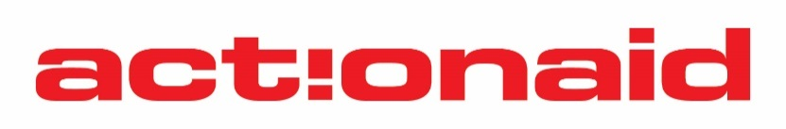

VACANCY ANNOUNCEMENT

ActionAid is an anti-poverty agency that prioritises work with people living in poverty and exclusion; promoting values and commitment in civil society, institutions, and Governments with the aim of achieving structural changes in order to eradicate injustices and poverty in the world. ActionAid Nigeria is an affiliate of ActionAid International, an International Non-Governmental organisation registered in The Netherlands with its headquarters in Johannesburg, South Africa. ActionAid International works in more than 40 countries in Africa, Asia, Europe, and the Americas.

ActionAid Nigeria is inviting applications from qualified candidates to fill the Humanitarian Youth Inspirator position within the organisation:

Humanitarian Youth Inspirator – Maiduguri, Borno

The post holder will be responsible for enhancing the capacities of partners, Activista, youth groups in implementation of the Youth in Crisis engagements as well as support the implementation of SPA II project actions.

Person Specifications

Education/Qualifications
- First degree in arts/humanities/social sciences or other related field is essential

Experience
- At least two (2) years post NYSC experience, one (1) of which should be in youth related programme in the humanitarian/development sector is essential.
- Experience working with youth and youth groups is essential.
- Knowledge of and experience in developing effective campaigns is essential.
- Experience in working with diversified groups in rural and semi-urban areas is essential.
- Experience in advocacy and mobilization as well as using digital platforms and mediums is essential

Skill/Abilities
- Report writing and research skills
- Ability to provide capacity building and support to people with diverse backgrounds and different degrees of digital expertise.
- Excellent analytical and negotiating skills.
- Fluency in spoken and written English language.
- Highly numerate with excellent multitasking skills
- Excellent planning and prioritization skills
- Excellent (proven) interpersonal skills
- Experience in coordinating training/meetings
- Zealous and passionate about young people and movements

To apply, kindly complete relevant application form accessed from https://nigeria.actionaid.org/jobs. Application form should be sent in an MSWord attachment to Vacancy.Nigeria@actionaid.org. Only electronically submitted forms will be considered. Submitted or Scanned CVs will be disregarded.

Please refer to the website - https://nigeria.actionaid.org/jobs for detailed terms of reference and application form.

Subject line of emails must state clearly, job title of position applied for and location e.g. Humanitarian Youth Inspirator– Maiduguri, Borno.

ActionAid offers competitive terms of employment. Applications from young people, women, persons with disability and candidates from the Northeast and Northwest are particularly encouraged.

Closing date for receipt of applications is 31st December 2025. While we respect all applicants, interview dates will be communicated only to shortlisted candidates.

ActionAid is committed to preventing any form of sexual harassment, exploitation and abuse (including child abuse and adult at-risk abuse) in line with our Child Safeguarding policy, Protection from Sexual Exploitation and Abuse; and Sexual Harassment, Exploitation and Abuse at Work Policy and Overarching SHEA and Safeguarding Policy; as well as our zero-tolerance approach to Safeguarding concerns.

